The BOMA Saskatchewan Golf Classic was held on Monday, August 30, 3021 at
Deer Valley Golf Club, and was presented by Johnson Controls Canada

President’s Cup – Lowest Scoring Teams was a tie: tied:  Commercial Building Service with Murray Sutherland, Ross Schwager, Scott Cody, and Michael Kelsey; and  Century West Disaster Restoration with Rob Johnson, Carmen Hiebert, Rob Barlow, and Kale Dolinski. | 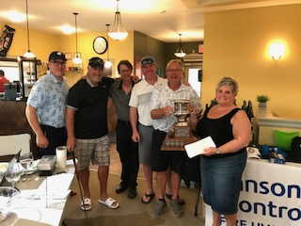
Don Holman Trophy – Most Honest Team –  Westdale Properties (Northgate Mall) with Alvin Martindale, Jim Robert, Kevin Lang, and Andrea McKay | 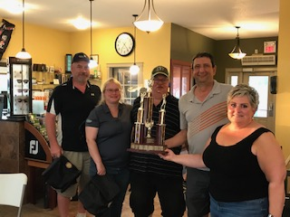
Closest to the Pin

Crista Carter of SGI and
Kirk Campbell with Johnson Controls

Longest Drives

Crista Carter of SGI and
Patrick Connell with Flynn Canada

Longest Putts  Crista Carter of SGI and  Curtis Dorosh of the Ministry of SaskBuilds & Procurement | 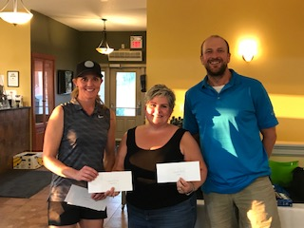
Winner of the Lost Balls Contest  Jeremy Schick of Avison Young | 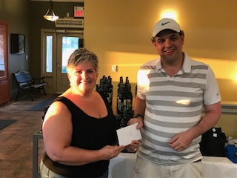

United Way Regina raised a total of $730 on the putting green and with the 50/50 draw! Judy Kelly and Coleman Walker did an amazing job running the putting green and selling 50/50 tickets.

Thank you to our MAJOR SPONSOR

Thank you to our PHOTO/WINE SPONSOR: GDI Services (Canada)/Ainsworth Inc.

Thank you, GOLD SPONSORS:

Thank you, SILVER SPONSORS:

THANK YOU TO:
HOLE IN ONE SPONSOR:

GOLF BALL SPONSOR:
SIGN SPONSOR: PLS Signage & Graphic
WATER SPONSOR: Regina Plumbing and Heating

HOLE SPONSORS:  - BGE Indoor Air Quality Solutions  - Dream Office Management (Sask)  - EB Contracting  - GDI/Ainsworth  - Harvard Western Insurance  - Hipperson Construction  - Hudson Energy/Just Energy Advance Solutions  - HVAC Sales/Service  - McCOR Management (SK) Inc.  - Regina Plumbing & Heating  - Trane Canada  - Viking Fire Protection  PRIZE DONORS:  - Commercial Building Services Ltd.  - Full Throttle/Full Steam  - IFMA Board of Directors  - Grundfos Canada  - PCL Construction Management  - Hudson Energy  - Harvard Western Insurance  - PLS Sign & Graphic  - Deer Valley Golf Club | THANK YOU to the Golf Committee and Volunteers During the Tournament:  - Chair – Justin Symes  - Cecelia Lang & Casey Lang  - Brandi Clarke  - Mitch Hoehn  - Greg Ruud  - Lisa Pegg  - ED Cail Maclean

