The BOMA Saskatchewan Golf Classic was held on Monday, August 29, 3022 at
Deer Valley Golf Club, and was presented by Johnson Controls Canada

President’s Cup – Lowest Scoring Team  Commercial Building Service with Murray Sutherland, Mike Hudey, Kelly Geissler and Scott Cody. | 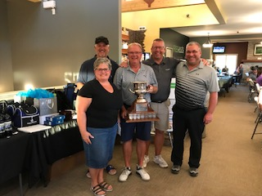
Don Holman Trophy – Most Honest Team  Imperial Dade Canada with Patrick Cooper and David Robinson. | 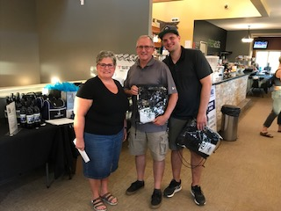
Closest to the Pin  Women: Sandy Doran of Colliers International  Men: David Higgins golfing with PLS Sign and Graphic | 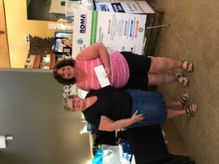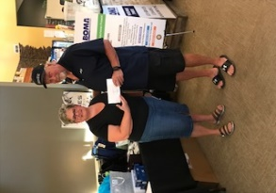
Longest Drives  Women: Dawn Schlosser of Nicor Group and  Men: Mitch Hoehn of PCL Construction Management Inc. | 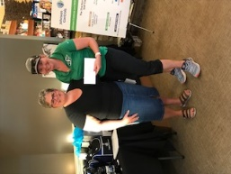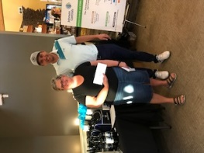
Longest Putts  Men: Doug Scutchings golfing with Seal-it Up Roofing  Women: Dawn Schlosser of Nicor Group and | 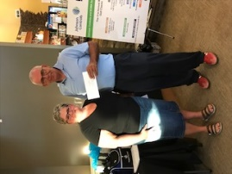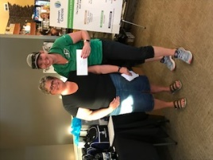
Winner of the Lost Balls Contest  Matt Wood golfing with Century West Disaster Restoration | 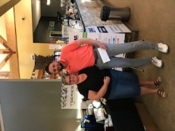

Regina Food for Learning raised a total of $1,015 on the putting green and with the 50/50 draw! Lin Gennutt and Jean Coleman did an amazing job running the putting green and selling 50/50 tickets.
Thank you to our MAJOR SPONSOR
_________________________________________________________

Thank you to our PHOTO/WINE SPONSOR: GDI Services (Canada)/Ainsworth Inc.

Thank you, GOLD SPONSORS

Thank you, SILVER SPONSORS

E.B. General Contracting

Thank You To
HOLE IN ONE SPONSOR:

GOLF BALL SPONSOR:
SIGN SPONSOR: PLS Signage & Graphic
WATER SPONSOR: Westdale Properties/Northgate Mall

HOLE SPONSORS:  - BGE Indoor Air Quality Solutions  - FlexNetworks  - GardaWorld  - GDI/Ainsworth  - GFL Environmental Inc.  - Harvard Western Insurance  - HVAC Sales/Service  - Lydale Construction  - Trane Canada  PRIZE DONORS:  - Ainsworth Inc.  - Commercial Building Services Ltd.  - Cushman Wakefield/Cornwall Centre  - Deer Valley Golf Club  - Flynn Canada  - Full Throttle Furnace & Duct Cleaning Inc.  - Hudson Energy  - PCL Construction Management Inc.  - PLS Sign & Graphic  - SGI  - Western CML Cleaners Ltd. | THANK YOU to the Golf Committee and Volunteers During the Tournament:  - Chair – Justin Symes  - Brandi Clarke  - Mitch Hoehn  - Cecelia Lang  - Wendy Kopeck  - Lisa Pegg  - Cail Maclean, ED

