35TH ANNIVERSARY AWARDS GALA DINNER REPORT
After cocktails in the Library, we packed the Blue Lounge at Hotel Saskatchewan for a fun-filled evening on May 17, 2023.
We were fortunate to have BOMA Canada's President & CEO, Benjamin Shinewald in attendance to bring greetings and to assist in making the BOMA BEST presentations.
After a delicious dinner, presentations of BOMA BEST Certificates and gift baskets were made by Chair Dawn Schlosser and Benjamin Shinewald of BOMA Canada to:
Ministry of SaskBuilds & Procurement - 11 certificates - Curtis Dorosh & Team
Innovation Saskatchewan - 8 certificates (not in attendance)
Cushman & Wakefield - 2 certificates - Katie Dockham, Darren Renner
Choice Properties REIT - 2 certificates - Andy Thomas
SaskCentral - 1 certificate (not in attendance)
Morguard Investments Ltd. - 1 certificate (not in attendance)
Black and McDonald Ltd. - 1 certificate - Travis Wasserman
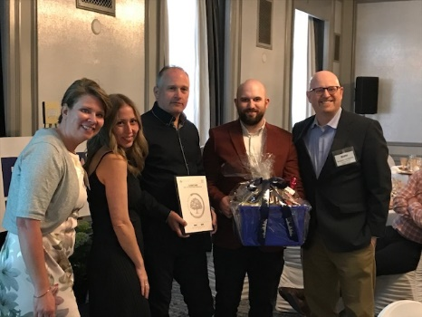 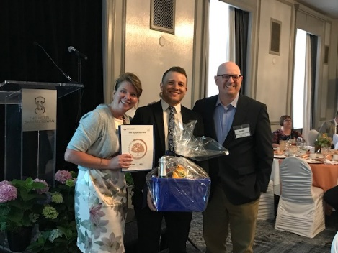
Cushman & Wakefield-Midtown Plaza, Cornwall Centre Black and McDonald 3455 Idylwyld Drive North

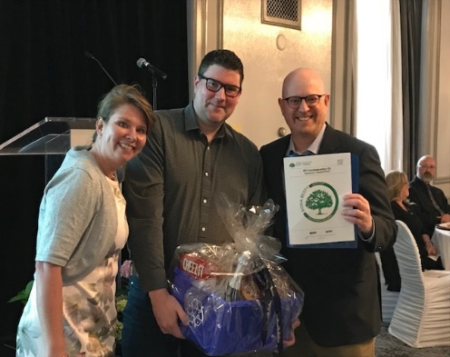 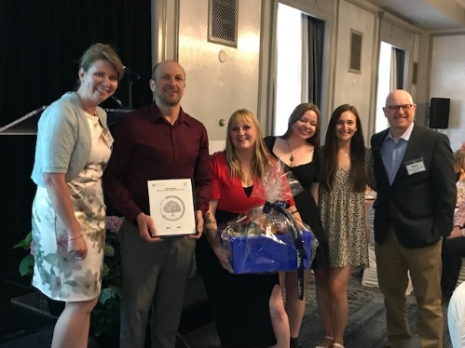
Choice Properties REIT 411 Confederation Dr. Ministry of SaskBuilds & Procurement Team
_______________________________________

The coveted EARTH AWARDS were presented by Dawn Schlosser and Benjamin Shinewald and the recipients are as follows:
Earth Award - Office - Innovation Saskatchewan for 121 Research Drive, Saskatoon (not in attendance)
Earth Award - Universal Property - Ministry of SaskBuilds & Procurement for Roy Romanow Provincial Laboratory, Regina - Curtis Dorosh & Team
Earth Award - Open Air Retail Property - Choice Properties REIT for 411 Confederation Drive, Saskatoon - Andy Thomas
Earth Award - Light Industrial Property - Ministry of SaskBuilds & Procurement for the Central Vehicle Agency Building, Regina - Curtis Dorosh & Team
Earth Award - Enclosed Shopping Centre Property - Cushman & Wakefield for Midtown Plaza Inc., Saskatoon - Darren Renner & Katie Dockham
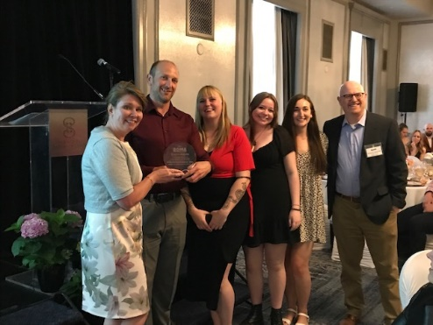 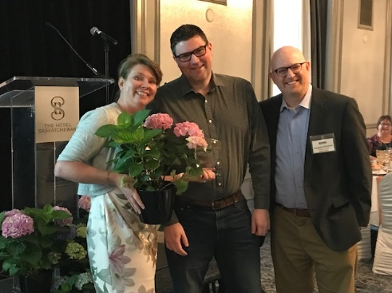
Ministry of SaskBuilds & Procurement Choice Properties REIT
_______________________________________
MEMBERSHIP MILESTONES
Were awarded as follows:
5-year
Cushman & Wakefield Asset Services
Hudson Energy
SBLP Southland Mall Inc.
Seal-It Up Roofing Ltd.
Victaulic
15-year
Macro Properties
Mitchell Developments Ltd.
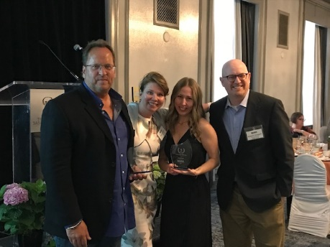
Recipient Adrian Leusink of Hudson Energy, Chair Dawn Schlosser, recipient Katie Dockham of Cushman & Wakefield with Benjamin Shinewald of BOMA Canada accepting 5–year awards Membership Milestones.
SPECIAL AWARDS

A special presentation took place to recognize Past President Agatha Potapinski as an Honorary Member.
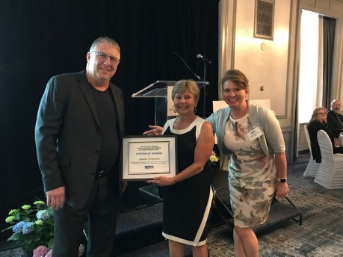
Brian Klenk, Vice-Chair with Aggie Potapinski and Dawn Schlosser
The Emerging Leader of the Year Award was presented to:
Kendra Wren, Cushman & Wakefield Asset Service
With Kendra being out of the province on business, a colleague, Katie Dockham, managed to reach Kendra via FaceTime so she heard first-hand that she had been the recipient of this new award.
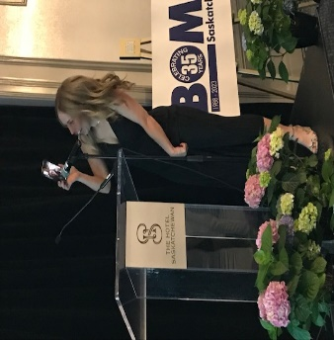
Katie Dockham has Kendra Wren on FaceTime during the presentation.
Next was the Lloyd Rogers Member of the Year Award that was presented to Past President
Lisa Pegg, GWL Realty Advisors
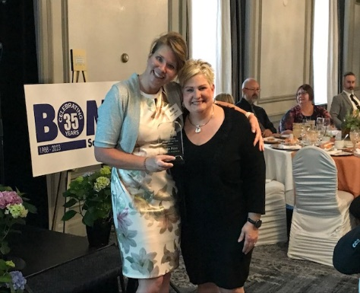
Chair Dawn Schlosser with Past Chair Lisa Pegg
And the final award of the night was the Chair's Award which is only presented every 5 years. Past President and BOMA Canada Director Victoria Gabel, Harvard Developments Corporation was
the recipient.
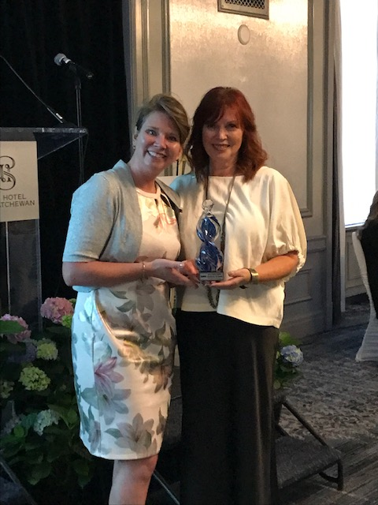
Dawn Schlosser and Victoria Gabel
It was time to sit back and enjoy comedian Joel Jeffrey entertain the crowd and he did that in spades. It certainly was a night to remember.
Thank you to our Wine Sponsor, Paladin Security
and our Treat Sponsor, Hudson Energy

