The Earth Award recognizes excellence in resource preservation and environmentally sound commercial building management.

Earth Award – Office - - Innovation Place  Lisa Pegg presenting to Mike Walch  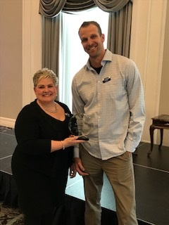 | 2 Research Dr., Regina  Innovation Place  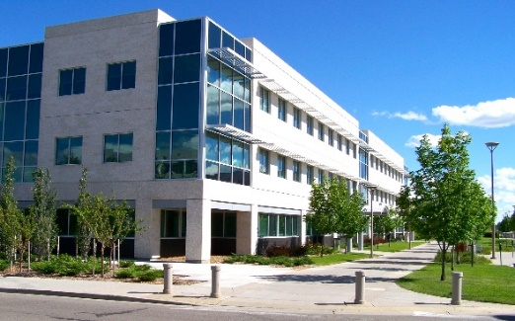

Earth Award – Universal – Innovation Place  Lisa with Raylene Kimmerly  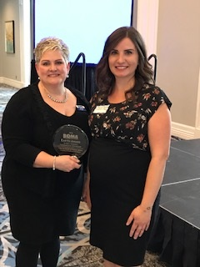 |  | Dr. Jack McFaull, Saskatoon  Innovation Place  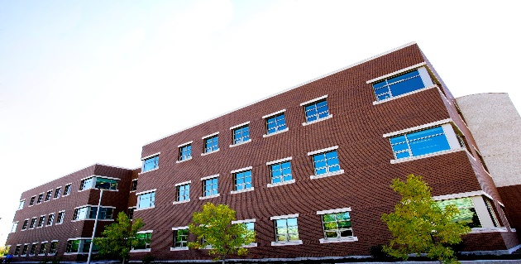
 | Earth Award – Light Industrial  Ministry of SaskBuilds & Procurement  Lisa with Curtis Dorosh  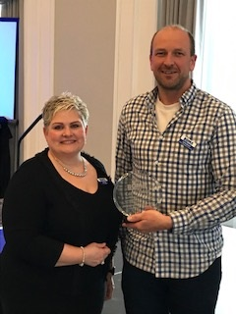 |  | Morse Equipment Storage Building  Ministry of SaskBuilds & Procurement  