The BOMA Golf Classic was held Monday, August 27, 2018 at Deer Valley Golf & Country Club, presented by GardaWorld.

RESULTS:
- Recipient of the President's Club - Western CML Cleaners - Lowest Score Team - John McFadden, Dave Oates, Ken Wilhelm and Len Staatz;
- Recipient of the Don Holman Trophy - Most Honest Team - Austin Stadnyk, Morris White, Madelyn Mushanski and Renee Bordynluk;
- Closest to the Pin - Pauline Tessier and Mike Tate;
- Longest Drives - Lana Lindseth and Ken Wilhelm;
- Longest Putts - Aggie Potapinski and Denis Mailhot;
- Winner of the closest guess to the number of balls lost - Garth Mann;
- Ronald McDonald House, Saskatoon, Marcelline Zimmer and colleague raised $1,160 on the putting green and with the 50/50 draw.

Thank you to our MAJOR SPONSOR, GardaWorld and to all sponsors:
​
GOLD SPONSORS:
​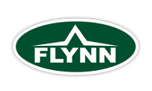​ ​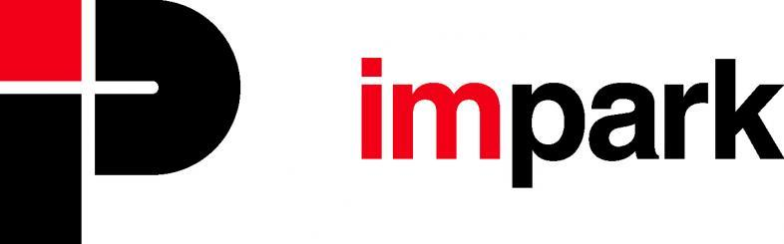​
SILVER SPONSORS:
​​

HOLE IN ONE SPONSOR: Altus Group & Harvard Western Insurance
SIGN SPONSOR: PLS Sign & Graphic
HOLE SPONSORS:
- Dream Office Management (Sask.) Corp.
- Grundfos Canada Inc.
- HVAC Service
- McCOR Management
- GDI Integrated Facility Services
- Hipperson Construction
- Pinchin Ltd.
- Marquardt Mechanical
WATER SPONSOR: Northgate Mall
PRIZE DONORS:
- GDI Integrated Facility Services - 2 Rider Tickets
- Commercial Building Services Ltd. - 4 Green Fees/Carts
- Deer Valley Golf Course - 4 Green Fees/Carts
- Pinchin Ltd. - 4 x $50 Golf Town Gift Certificates
- McCOR Management - 4 Throw Blankets
- Impark - 4 Golf Shirts
- Association of Regina REALTORS(s) Inc. - 4 Cooler Bags/Tea Fuser Tumbler
- Innovation Place - 4 Water Bottle in Bags
- Western CML Cleaners - 4 Folding Chairs
- Hudson Energy - Men's Golf Shirt, Men's Golf Pullover and 2 Boxes CP Canadian Open golf balls
- PLS Sign & Graphic - 2 Putters & 4 Hats
- Crown Shred & Recycling - 4 Golf Shoe Bags/Sleeve of golf balls
- Ritenburg & Associates - Google HOME

THANK YOU TO THE GOLF COMMITTEE + VOLUNTEERS:
- Chair - Wendy Kopeck
- M.C. Murray Sutherland
- Chris Johnson
- Kevin McEwen
- Lisa Pegg
- Casey Lang
- Cail Maclean

