
BOMA
Saskatchewan
2026
Submission Guidelines:

Building Operations Team of
the Year
Award

Your completed submission and application fee of $50 (+ GST) must be received by May 1, 2026:
BOMA Saskatchewan
Box 20013, 2102 11th Ave.
Regina SK S4P 4J7
events@bomasask.ca

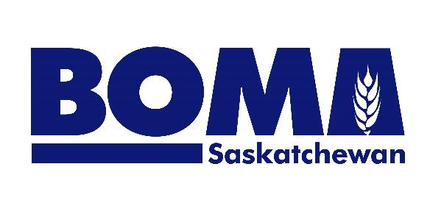
The Building Operations Team of the Year Award celebrates the success of the Team that shows a high level of expertise in scheduling preventive maintenance; improving general building operations; and ensuring maximum energy efficiency.

Eligibility:
- The company must be a BOMA Saskatchewan member
- Operations teams, property management companies, and owners may enter
- The team must be in charge of the operation and daily maintenance of the building(s)
- A company with more than one building may enter multiple entries but only one team per building is eligible. Each Team must be made up of different people.
- Entries are by self-nomination accompanied by the $50+GST application fee.
- Judging will be based on your written submission and meeting of all requirements

Submission Requirements:
- Guidelines for written submission are outlined below
- A cover sheet stating the following must be included:
  - Names & Titles of People on the Team
  - Company name
  - Building Name(s)
  - Submitter’s name & contact information for all correspondence.
  - Which type of maintenance you provide:
- Predictive and preventive maintenance - procedures conducted to the manufacturing specifications with frequent inspections, adjustments, lubrication, and parts replacement according to a planned maintenance schedule.
- As needed or occasional maintenance - some parts replacement but not on a fixed schedule, emergency repairs, start-up/shutdown procedures and planned major and unplanned minor overhauls.
- Please provide, by email or on a disc, 3-5 high resolution images including one group shot of the entire team, action shot(s) of the team at work, and a company logo

Site Visit and Document Review:
Entrants will be contacted by the judges to arrange a site visit, which will last approximately 1.5 hours. All mandatory documents must be included with the submission or available for review during the site visit.

Summary of Judges Scoring:
The total potential score is 70 points, as outlined at the end of this document. A minimum of 70% or 49 points must be earned to be eligible.

By applying, applicants acknowledge and accept the following terms & conditions:
Judging results are verified by BOMA Saskatchewan. All results are final and are not subject to appeal. BOMA Awards Committees & Judges are industry representatives who volunteer their time & expertise for this program. Photographs may be used in awards program materials & media.

Written Submission Questionnaire (70 points)

1. Safety | Potential Points
a) Is there anything above and beyond the norm that occurs at the safety training and/or meetings for the employees? Describe. | 3 points
b) Describe how Fire and Smoke Systems are maintained. | 3 points
c) How does the team keep up to date on all things related to Workers Compensation Board or WorkSafe regulations? | 3 points
Mandatory Documents:
OH & S Meeting Minutes attached OR available on-site
Annual Fire & Safety Compliance Testing attached OR available on-site
Proof of WHIMIS/MSDS Compliance attached OR available on-site | 1 point
Emergency Preparedness Plan attached OR available on-site | 1 point

2. By-laws, Building Codes and Regulations | Potential Points
a) How do you ensure all building by-laws and building codes are met | 3 points
b) How do you comply with all Technical Safety Authority of Saskatchewan regulations including the Boiler, Pressure Vessels & Refrigeration, Electrical, Elevator and Gas regulations? | 3 points
Mandatory Documents:
Elevator Maintenance Log attached OR available on-site no elevators

3. Maintenance | Potential Points
a) What is the team doing above and beyond the norm to oversee and/or maintain: Mechanical control systems; Electrical systems; Water treatment; Other | 4 points
b) Describe how the team performs lighting maintenance to the company’s standards and tenant standards. | 3 points
c) What is the process for monitoring custodial work and supplies? | 3 points
Mandatory Documents:
Waste Management & Recycling Plan attached OR available on-site | 2 points

4. Energy Management | Potential Points
a) How does the team monitor energy consumption? | 3 points
b) What is the biggest energy management opportunity in your building(s)? Why? | 3 points
c) Does anyone on the team advise the Owner’s Senior Property Manager of energy saving opportunities? If yes, describe a time when this was done. | 3 points
Mandatory Documents:
Energy Management Plan attached OR available on-site

5. Tenant Services | Potential Points
a) Describe the procedure for dealing with tenant complaints/service requests. | 3 points
b) How does the team make sure tenants are satisfied? | 3 points
Mandatory Documents:
Tenant Manual attached OR available on-site
Tenant Work Order System attached OR available on-site

6. Team Synergies | Potential Points
a) Describe how team building is encouraged. | 3 points
b) How is everyone on the team informed of any changes? | 3 points
c) How do people on the team show leadership? | 3 points

7. Other | Potential Points
a) How do you ensure all documents are up to date and filed for future reference? | 3 points
b) How do you oversee construction projects to eliminate defaults? | 3 points
c) How is the Property Manager kept informed on the progress of construction/renovation projects? | 3 points
d) Does the team decide or influence the decision of which contractors to use? If yes, how do you determine the value you receive from those contracts? | 3 points
e) List any designations or certificates that people on your team have that are related to their job. | 3 points
f) Describe a program or idea that came from someone or several people on the team that either improved the operations management of the facility, or resulted in measurable improvement. It must have been completed by a team member. | 2 points
TOTAL POINTS OF ALL SECTIONS: 70

