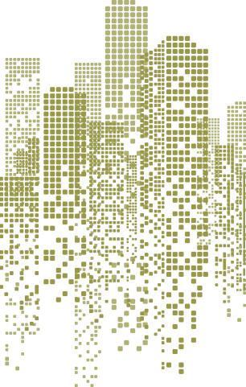

BOMA
Saskatchewan
2026

Earth Awards

Local winners will be eligible to enter the BOMA Canada National Awards provided national entrance criteria are met.

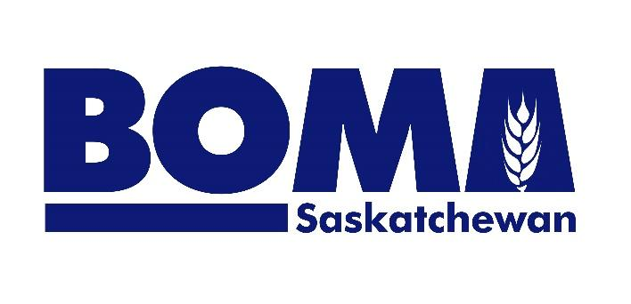

Earth Awards recognize excellence in resource preservation and environmentally sound commercial building management.

- All Buildings that achieve BOMA BEST® certification through BOMA Saskatchewan within the annual awards cycle (April 1, 2025 – March 31, 2026) are automatically entered.

- No application is necessary.

- The Earth Award is presented to the building that obtained the highest overall BOMA BEST® score in each of the following asset classes:

  - Office – must be at least 50% office area;
  - Industrial Office - industrial properties with more than 5% and less than 50% office area;
  - Retail - enclosed or open-air shopping centers or power centers. No minimum office area is required;
  - Multi Unit Residential - buildings comprised of a common entrance and separate dwelling units;
  - Health Care Facility (Hospitals/Medical Office Buildings) – to qualify as a hospital, more than 50% of the gross floor area of all buildings must be used for general medical and surgical services; AND more than 50% of the licensed beds must provide acute care services; AND these facilities must operate on a 24/7 basis; to qualify as a medical office building, more than 50% of total facility space is used primarily to provide diagnosis and treatment (no major surgery) for medical, dental, or psychiatric outpatient care; and do not operate on a 24/7 basis;
  - Universal – College/Universities, Courthouses, Museums, etc. (No use or size restrictions)

All entrants acknowledge and accept the following terms & conditions:
Judging results are verified by BOMA Saskatchewan. All results are final and are not subject to appeal. BOMA Awards Committees & Judges are industry representatives who volunteer their time & expertise for this program. Photographs may be used in awards program materials & media.

