

BOMA
Saskatchewan
2026
Emerging
Leader Award

Your completed submission must be received by May 1, 2026:
BOMA Saskatchewan
Box 20013, 2102 11th Ave.
Regina SK S4P 4J7 or by email to:
events@bomasask.ca

No application fee required.

Local winners will be eligible to enter the BOMA Canada National Awards provided national entrance criteria are met.

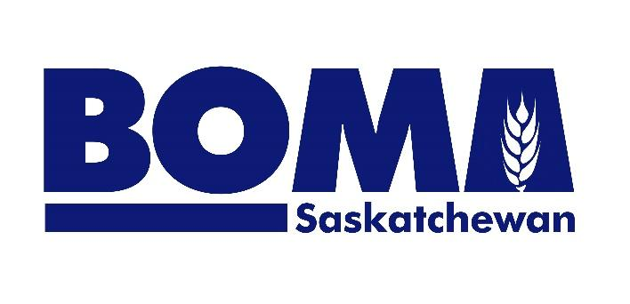

The Emerging Leader Award recognizes individuals in the Commercial Real Estate Industry who has demonstrated excellence, inspired their team members and are well on their way to becoming the next leaders in the profession. This award recognizes leadership, initiative, and/or service to the commercial real estate community. The award will be presented to an individual 40 years of age or younger who has significantly contributed to their organization and/or the Commercial Real Estate Industry.

Eligibility

- Nominees must be a BOMA Saskatchewan member to be eligible
- Only emerging leaders are eligible for this award

An emerging leader is defined as a BOMA Saskatchewan member working full-time in commercial real estate either in property management or as a supplier and who is 40 years of age or younger.

Submission Requirements

- A cover sheet stating the following must be included:
  - Name & Title of Entrant
  - Company Name
  - Phone number
  - Email address

- High resolution [EPS, PNG, JPG] headshot of the individual and logo of the individual’s company must accompany the entry. (These images may be used during the awards luncheon and in post-event editorial coverage)
- A written submission supporting the efforts and achievements that qualifies the entrant as an Emerging Leader. (Minimum 600 words/Maximum 1,000 words)
- Supporting documentation must be provided, demonstrating evidence on how the selection criteria have been achieved. (Submission should not exceed 3 pages in total including cover sheet.)
- Award nominees will be evaluated on:
- Job performance
- Professionalism
- Innovation
- Leadership
- Team building
- Entrants will be evaluated primarily on recent achievements. A track record over time will also be considered.

All entrants acknowledge and accept the following terms & conditions:
Judging results are verified by BOMA Saskatchewan. All results are final and are not subject to appeal. BOMA Awards Committees & Judges are industry representatives who volunteer their time & expertise for this program. Photographs may be used in awards program materials & media.

