The Earth Award recognizes excellence in resource preservation and environmentally sound commercial building management.

Earth Award – Office  2 Research Dr., Regina Innovation Place  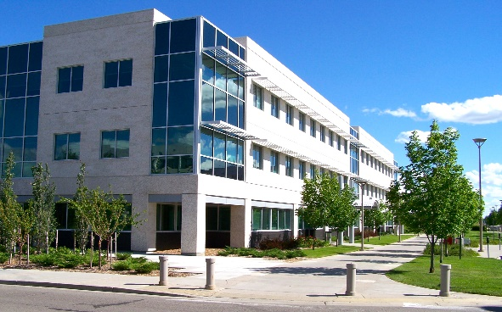 | Earth Award – Universal  Dr. Jack McFaull, Saskatoon  Innovation Place  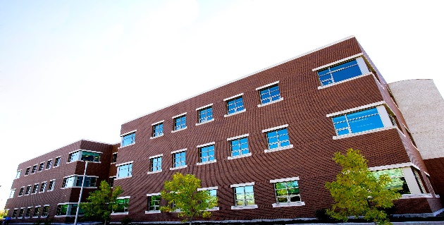

Earth Award – Light Industrial  Morse Equipment Storage Building, Ministry of SaskBuilds & Procurement  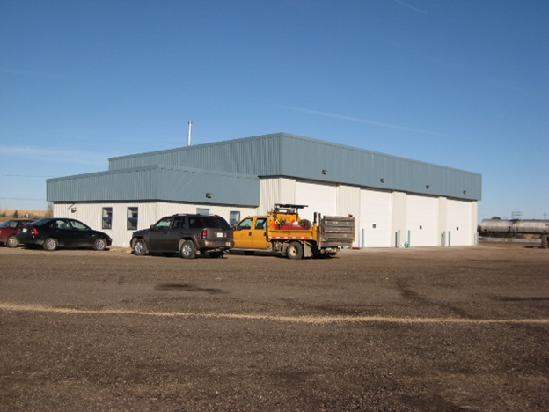 |  | Building Operations Team of the Year Award – celebrates the success of the Team that shows a high level of expertise in scheduling preventive maintenance, improving general building operations; and ensuring maximum energy efficiency.  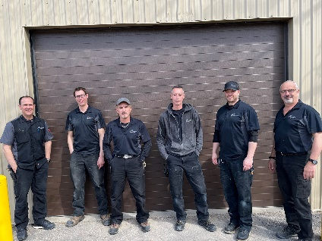  Liam Carroll, Leif Sperling, Curtis Halliday,  James Fenez, Rob Dereniwski and Calvin Pauls
 | Emerging Leader of the Year Award  Josh Hextall, Trane Canada  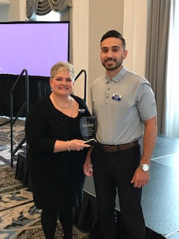 |  | Lloyd Rogers Member of the Year Award  Jim Park, Security Lock & Key  